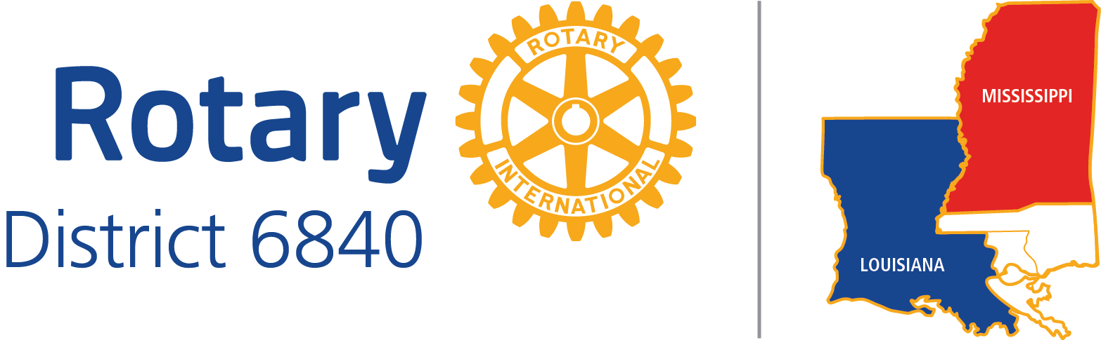

CLUB LEADERSHIP OBJECTIVES

POSITION TITLE: CLUB SECRETARY Date: December 31, 2016

DISTRICT EXPECTATIONS:

A Club Secretary is expected to:

1. Maintain a complete and accurate database of club member information on ClubRunner or DACdb and sync it with the Rotary International database at least monthly. This is crucial for club, district, Zone and R.I. generated reports, notifications, information, requests, etc.

2. Reply promptly to District inquiries

3. Fulfill any tactics assigned to Club Secretaries in the District Long-range Plan.

4. Attend District Meetings Before your year begins:
District Training Assembly
District Conference
As many other District meetings as possible

During your year:
Summer Seminar (Rotary Foundation, Membership, PR)
District Conference
As many other District meetings as possible

BEST PRACTICES:

1. Attend Rotary Leadership Institute

2. Monthly update information in Rotary Club Central after the initial information in entered by the club president.

3. Keep track of attendance and service participation so that remedial action can take place for non-
engaged members.

4. Have sufficient access authority to ClubRunner or DACdb to carry out his/her tasks.

5. Have log-in ability on rotary6840.org and rotary.org.

For technical support for DACdb, contact the DABdb support team, or contact the Zone 30-31 Communications Officer/ Database Coordinator.

