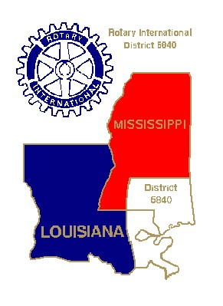

RESULTS OF DISTRICT 6840 SWOT ANAYLYSIS
AUGUST 23, 2014
(75+ Attendees)

Rotarians rated the suggestions. Listed are the top five results in each area. * means the result was rated twice as highly as the next item in that category

Strengths
- Leadership*
- PETS
- Financial support
- District Conference
- Youth Exchange

Weaknesses
- District communications to members
- Rotary education

- Member engagement
- Racial diversity
- Resistance to change

Opportunities
- Community leadership
- New members
- Interact and Rotaract expands Rotary family
- Rotary branding
- Visibility

Threats
- Apathetic membership*
- Lack of youth in clubs
- The economy
- Loss of club leadership for district
- District relevance

