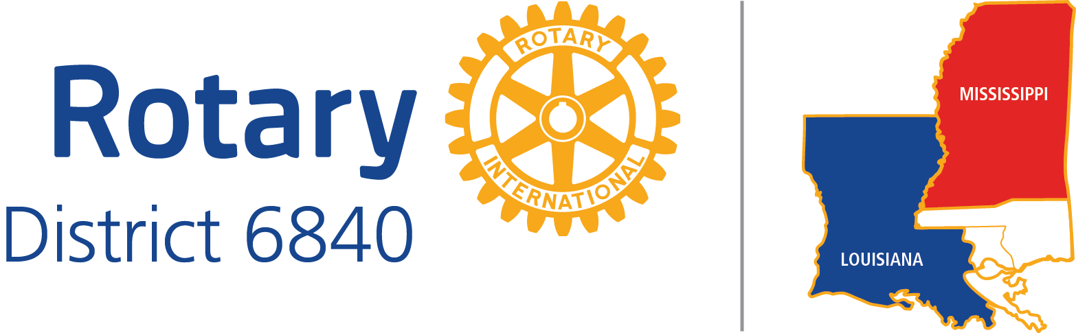

CLUB LEADERSHIP OBJECTIVES

Date: December 23, 2016

POSITION TITLE: CHAIR FOR COMMUNITY SERVICE

DISTRICT EXPECTATIONS:

1. Leads the club to do effective and appropriate service projects.

2. Regularly updates the Deputy Governor for Service on the projects the club undertakes.

3. Responds promptly to District inquiries.

4. Implements any initiatives assigned in the district strategic plan.

5. Brings sense of creating service opportunities for every club member.

6. Attends District Meetings

Before your year begins:

1. District Training Assembly
2. Foundation Grants Seminar
3. District Conference

During your year:

4. Mid-year Check-up
5. District Conference

BEST PRACTICES:

1. Attends Rotary Leadership Institute Parts I, II, and III.

2. Creates priorities for club service projects through club member input.

3. Uses priorities to assure that service projects are a worthwhile investment of time and resources.

4. Creates goals for community service.

5. Seeks partnerships with other clubs and non-profit and for-profit organizations to achieve service goals and effective community service projects.

