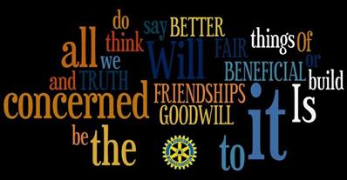

ROTARY DISTRICT 6840
COMMUNITY VISION STATEMENT

Based on our shared values and principles, we, the Rotarians of District 6840, have a vision for the communities in which we live.
We see our cities, towns and neighborhoods as places where we and our neighbors are fully engaged in the process of making this region a better place in which to live, where all of us accept personal responsibility for our actions, where the ability of our families to live in a safe and healthy environment is not an expectation or a hope, but a reality, and where opportunities for advancement are available for all.
We see the Four-Way Test as a living, breathing document which our governmental and business leaders use as a guide to help them act in the best interests of the people when confronting the crucial issues of our time including access to healthcare, educational achievement, and the elimination of discrimination, among others.
We see our region populated by people who view themselves not only as citizens concerned with our local interests, but also as citizens of the world concerned with and acting for the welfare of people around the globe.
In short, we see our region as dynamic and enriching interrelated communities, made up of motivated people who act in concert for the common good, so that our families are able to thrive and grow in a place they are proud to call home.

March 24, 2014

