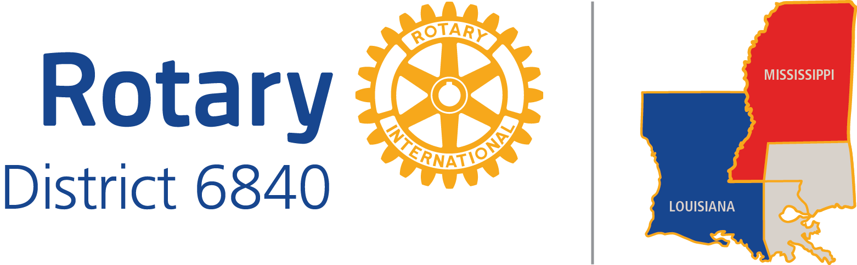

ROTARY DISTRICT 6840
PRESIDENTS’ SURVEY RESULTS
2013-14

July 20, 2014

Thirty-five clubs responded: 19 by the form via e-mail, 15 by phone, and one by an e-mail in a narrative form: 65%.
Seven did not respond to phone messages.
One did not respond to an e-mail message.
Three were sent surveys again but did not respond.
One said he was too busy.
Three had no successful phone numbers for the president and secretary.
Three clubs had presidents who did not serve a full year.
One club went inactive.
Question 1. What three things did the District do for you this past year as president that you valued?

- District Meetings – 32
  - Good to know you are not alone
  - Good ideas, easy to implement
  - Training – 5
  - PETS – 11
    - Challenges faced by other clubs

Ideas from other clubs - 2

Showed R.I. goals

District Conference - 8

Fun

Recognition

Mid-year check-up – 2
  - Rotary Leadership Institute – More useful than PETS.

Governor visiting club – 9
  - Wished it could have been in mid-year to recharge us.

Encouragement from DG and AG and DGND- 8

Always ready to help.

E-mailing updated information – 6

From DGE

Opportunities for District Involvement – 4

Reached out to encourage participation

Liked meeting other Rotarians

Friendships

District Grant – 4

information

District Governor’s newsletter – 3

Accessibility to district leadership and district club leadership - 3

Assistant Governors - 2

RYLA - 2

General Resources – 2

On-line

Prompt customer service - 2

Not much - 2

Strategic Planning Process

Good to know there is a vision for the future.

GSE

Selection of DG from our club

Food Fest

Presidents’ Survey Call

Club visit by president of another club.

Got me married

Taught me how to run meetings

Question 2. What three things did the District not do for you that you would have appreciated?

- Notifications – 5
  - Longer lead times on notices.
  - Proper notification of certification training for District Grants.
  - Earlier identification of expectations from District for money raising like Paul Harris Fellows.
  - More promotion about R.I. Scholarships especially because of the changes to Ambassadorial scholarships.

- More leadership training for presidents and officers. – 4
  - Alternate meetings other than the weekends for presidents and president-elects to get together.
  - Templates for incoming presidents
  - Parliamentary procedure

- E-mails - 3
  - Should be sent to President-Elect, VP, Secretary, also.
  - Secretary got e-mails that the President did not get.
  - President did not get all the e-mails that should have gone to him.
  - E-mail reminders before the annual meeting for awards.
  - The directory is not getting changed after information is forwarded.

- Encouragement. Good Will. – 3
  - More presence from District leadership at club luncheons
    - at least quarterly
    - twice a year

- Explanation of what the District is supposed to do for us. - 3
  - Explain what District projects mean to us and the District.

- Meetings - 3
  - location
    - Mid-year Check up - new location
    - Poplarville on Saturdays difficult to get to. Perhaps regional meetings every two months.
  - More times available for grant certification.

- District Grants – 3
  - Proper notification of certification training for District Grants
  - More money for individual District grants.
  - More times available for grant certification.

- Set priorities. Too many programs to choose from. Help us focus. – 2
  - More detail and personal engagement about priorities and how our club could help.

- District Directory - 2
  - Update it.
  - Responsiveness to corrections sent in.

- Share accounting of the District.

- More assistance with a club issue.

- More information on best practices especially about non-fundraising ideas.

- Took for granted that I knew about how to use the internet

Question 3. What three things did the District do for you that you did not find useful?

- District Meetings - 20
  - District Conference – 8
    - District Awards - 3
      - Method of handling recognition at the District Conference.
      - Lack of knowledge of District leadership about awards.
      - Too many awards at the same time.
    - Meeting facility – District Conference was not in building with hotel.
    - Having the same speaker at PETS and the District Conference.
    - Having to take time off during the workweek to attend the District Conference
    - Raffle - 2
  - Mid year check up – 2
  - Training should be more focused and less general. - 2
  - Need to provide more than just another meeting to attend. – 2
    - Meetings that did not provide information/education
  - PETS - 2
    - Training only on the weekend.
    - Having the same speaker at PETS and the District Conference.
  - Grant workshop
  - Meeting locations
  - Programming did not speak to younger Rotarians
  - District Events could have been more organized and run more efficiently. Seemed to be from the top down rather than with the needs of the club presidents in mind.

- E-mails – 2
  - Pressuring for not meeting deadline. Bad tone. Not “beneficial to all concerned.”
  - Asking for funds for District needs.
  - To sponsor a student exchange.
  - Too many

- Too much required. - 2
  - Too much information to process in one short year as pres.
  - Too much to accomplish in one year, especially for smaller clubs.
  - Need a longer term approach to achieving goals
  - Fewer and more targeted goals.

- Club runner is not a “fluid” source of District information.

- Shoes for Orphan Souls

- The District does not offer regular club members valued services

Question 4. What are the three most pressing needs of your club?
- Membership – 26

  - Retention – 6
  - New Members - 9
  - Competition for volunteers from other non-profits and for-profits that have paid staff. Volunteers do not have to pay dues. We need more reasons to join like emphasizing business referrals.
  - Pursue quality not quantity
  - Diversity
  - Young members

- Involvement of more of our members. – 12
  - In new crucial project
  - Focus engagement
  - Better attendance at luncheon meetings - 2
  - Delegation of heavy workload to others
  - 25% of the club participates; 50% don’t

- Funds/Finances – 8
  - Small clubs need help.
  - Grants for projects.
  - Ability to afford a Rotary exchange student.
  - Fund-raising ideas. – 3
e) Capital need for one of their projects.

- Developing projects appropriate for the club. – 5
  - Community service specifically - 3
  - A sensitivity to overall community needs.
  - International Programs expansion – 2

- District Connectiveness - 2
  - Getting club to learn what the district offers.
  - Knowing that we have a place in the district.

- Bridging age gap among members. – 2

- Planning – 2

  - Establish a long-term vision of avenues of service.
  - Re-evaluate current projects and activities to better help the community.
  - Re-evaluate objectives and goals of club foundation.

- Public Relations - 2
  - Media Relations

- Succession Plan - 2

- Sensitivity within club for restricted hours that some officers and members are able to give.
  - Have to do things differently from the past.

- Ideas for mentoring new members.

- Orientation of members to R.I. history and purpose

- Getting speakers for a small club.

- Leadership/Vision

- Foundation Giving

Question 5. What is the most effective way of contacting you? [Rate them 0-10, 10 being highest].

- Phone Call: range of 0-10 7.03
- E-mail: range of 5-10 8.80
- Newsletter: range of 0-10 5.43
- Personal Meeting: range of 0-10 6.08
- Other: [Just a few mentions for each]
  - Facebook: range of 8-9
  - Texting: range of 3-10
  - Snail mail: range of 8
  - District website range of 8

Question 6. What District representative did you hear from most often this year? [Check one]
1. District Governor Barbara Mauldin 14
2. District Governor Elect Brian Hall 3
3. District Governor Nominee John Cornwell 0
4. District Governor Nominee Designate Randy Feldman 4
5. The Assistant Governor assigned to your club 13
6. Other
a. Ken Thompson, i.e. the Newsletter 2

Question 7. On a scale of 0-10, 10 being highest, how would you value overall district services this year?
Range: 4-10. 7.7

Question 8. Does your club have a committee chairman for the following?

Public Relations
Yes 22
No 12

Club Administration

Yes 17
No 17

Membership

Yes 20
No 14

Service Projects

Yes 26
No 8

Foundation

Yes 18
No 16

